**How to see which classes group 1LMA2 has on 06/03/2020:**

1. Open your browser of choice and search for digitap
2. Open the link that leads to intranet.ap.be (this is probably the first link)
3. If you’re not logged in already, make sure to login with your digitap account
4. To the right, in the “Informatie en links voor …” you will find a button called “Agenda/Webuntis”, as highlighted in yellow in the picture bellow. Upon pressing this button you will be redirected to the homepage of webuntis. 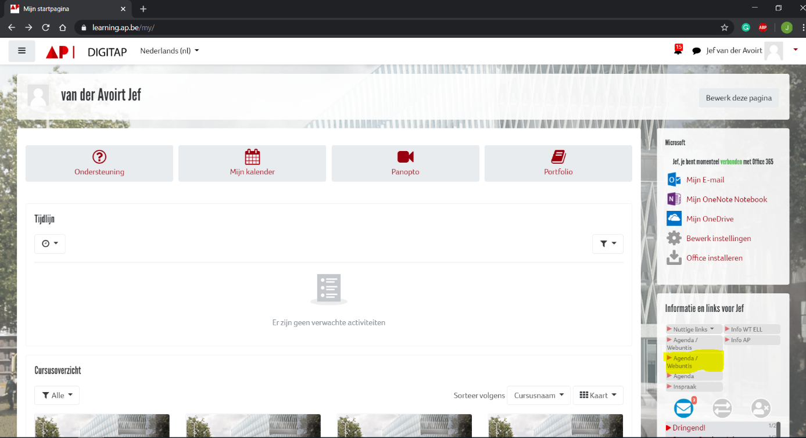
5. Now on your left press on the agenda icon, it is highlighted with a red circle in the picture below.

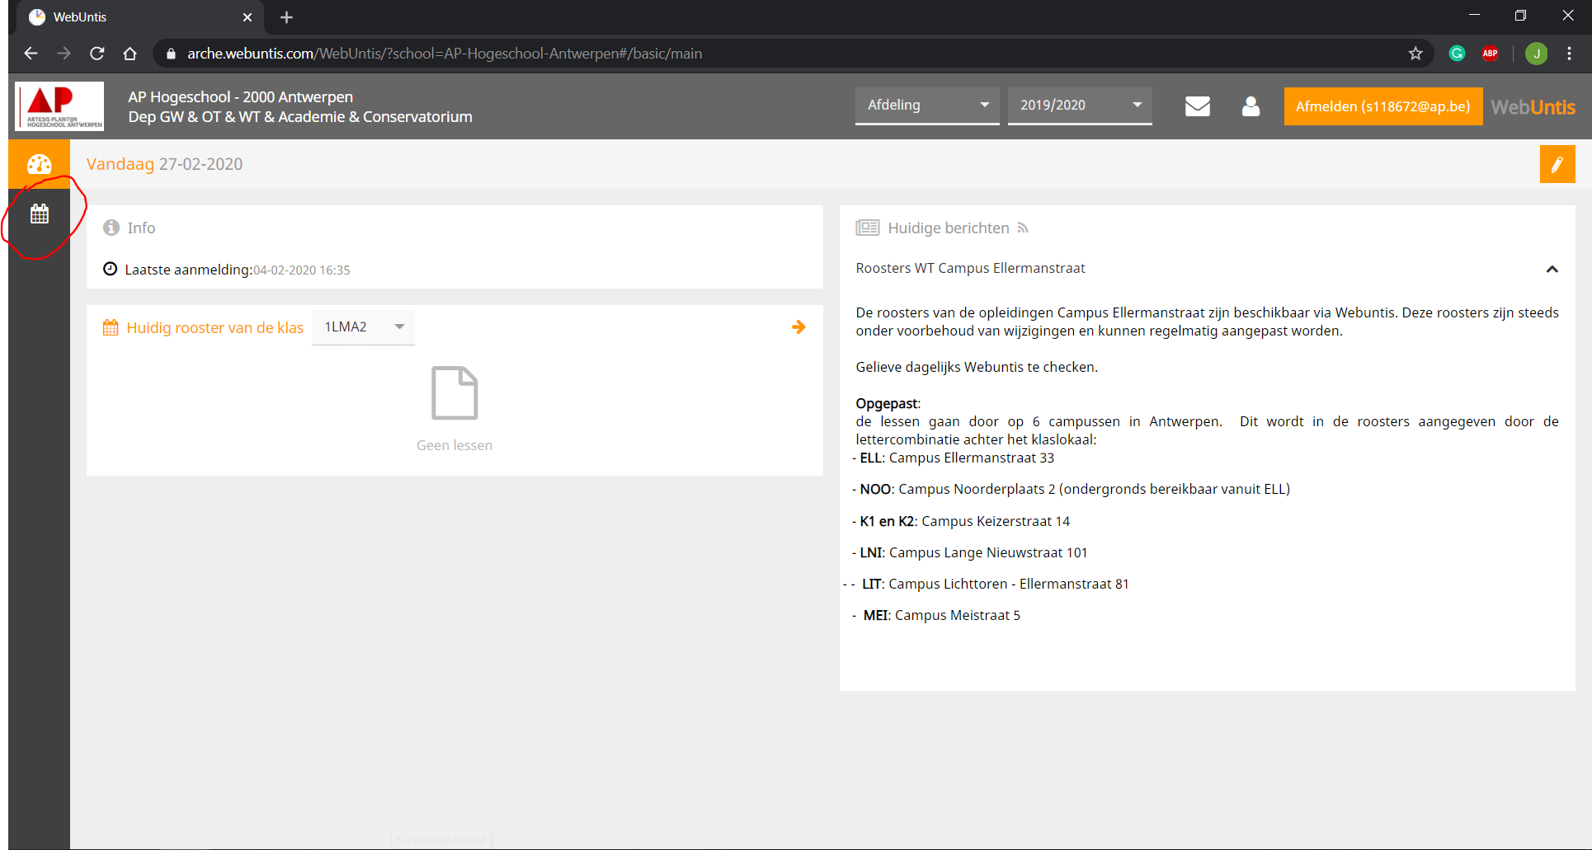

1. Here you will see an input field with the group of your choice. Search for “1LMA2” and select this group. If you are not sure where the input field is, it is again highlighted in yellow in the picture below. 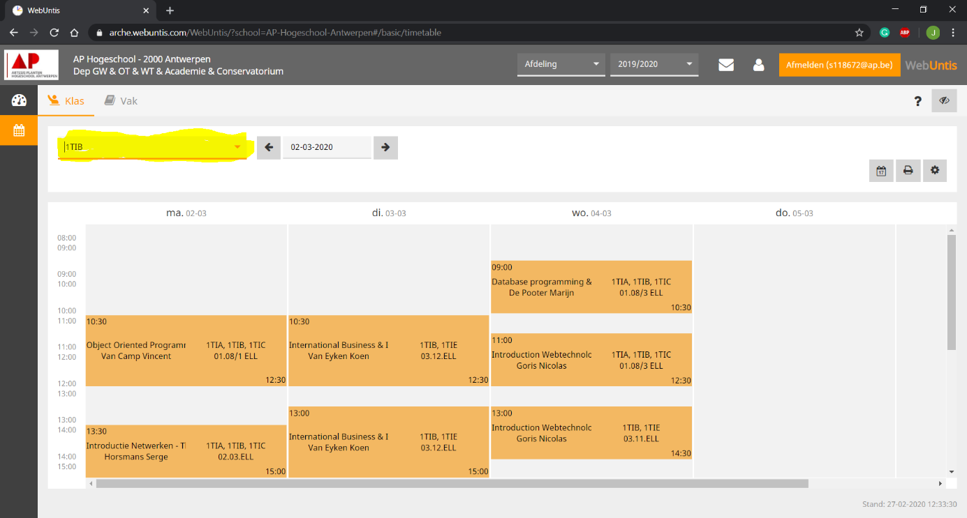
2. Next up, Select the week which we want to see our classes for. In our case this would be the week of the 6th of march. It is again highlighted in yellow in the picture below. 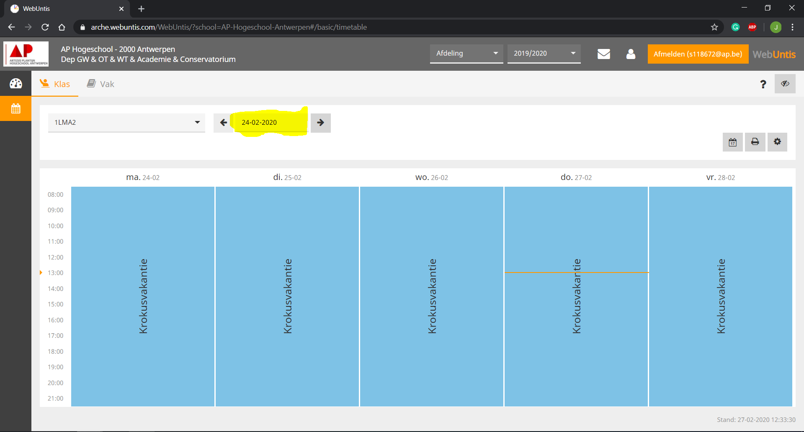
3. Once you did that, you will be able to see what classes the group 1LMA2 has on Friday the 6th of march. Just like you can see on the picture below. 